**Lab 7 Assignment Submission**

*Yash Srivastava*  
*220962368*  
*01/03/2025 (****Lab 7 Assignment****)*

**1. Passing Multiple Parameters Between Web Pages in Django  
2️. Django Session-Based Page Navigation with User Input Transfer  
3️. Grocery Checklist Web App with Dynamic Table in Django**

**Project Structure:**

Lab7/

│── manage.py

│── Lab7/ # Main project settings

│ ├── __init__.py

│ ├── settings.py

│ ├── urls.py

│ ├── wsgi.py

│

├── carapp/ # App for car manufacturer selection

│ ├── migrations/

│ ├── templates/carapp/

│ │ ├── car_form.html

│ │ ├── car_display.html

│ ├── __init__.py

│ ├── views.py

│ ├── urls.py

│

├── sessionapp/ # App for session-based page navigation

│ ├── migrations/

│ ├── templates/sessionapp/

│ │ ├── firstPage.html

│ │ ├── secondPage.html

│ ├── __init__.py

│ ├── views.py

│ ├── urls.py

│

├── groceryapp/ # App for grocery checklist

│ ├── migrations/

│ ├── templates/groceryapp/

│ │ ├── grocery_list.html

│ ├── static/groceryapp/

│ │ ├── styles.css

│ ├── __init__.py

│ ├── views.py

│ ├── urls.py

**Lab7/settings.py:**

INSTALLED_APPS = [

…

'carapp',

'sessionapp',

'groceryapp',

]

**Lab7/urls.py:**

from django.contrib import admin

from django.urls import path, include

urlpatterns = [

path('admin/', admin.site.urls),

path('carapp/', include('carapp.urls')),

path('sessionapp/', include('sessionapp.urls')),

path('groceryapp/', include('groceryapp.urls')),

]

**Car App (App 1)**

**carapp/views.py:**

from django.shortcuts import render

from django import forms

class CarForm(forms.Form):

MANUFACTURERS = [('Toyota', 'Toyota'), ('Ford', 'Ford'), ('Honda', 'Honda')]

manufacturer = forms.ChoiceField(choices=MANUFACTURERS, label="Select Manufacturer")

model = forms.CharField(max_length=100, label="Enter Model Name")

def car_form(request):

if request.method == 'POST':

form = CarForm(request.POST)

if form.is_valid():

manufacturer = form.cleaned_data['manufacturer']

model = form.cleaned_data['model']

return render(request, 'carapp/car_display.html', {'manufacturer': manufacturer, 'model': model})

else:

form = CarForm()

return render(request, 'carapp/car_form.html', {'form': form})

**carapp/templates/carapp/car_form.html:**

<form method="POST">

{% csrf_token %}

{{ form.as_p }}

<button type="submit">Submit</button>

</form>

**carapp/templates/carapp/car_display.html:**

<h2>Car Details</h2>

<p>Manufacturer: {{ manufacturer }}</p>

<p>Model: {{ model }}</p>

<a href="{% url 'car_form' %}">Go Back</a>

**carapp/urls.py:**

from django.urls import path

from .views import car_form

urlpatterns = [

path('', car_form, name='car_form'),

]

**Session App (App 2)**

**sessionapp/views.py:**

from django.shortcuts import render, redirect

def first_page(request):

if request.method == 'POST':

request.session['name'] = request.POST.get('name')

request.session['roll'] = request.POST.get('roll')

request.session['subject'] = request.POST.get('subject')

return redirect('second_page')

return render(request, 'sessionapp/firstPage.html')

def second_page(request):

name = request.session.get('name', '')

roll = request.session.get('roll', '')

subject = request.session.get('subject', '')

return render(request, 'sessionapp/secondPage.html', {'name': name, 'roll': roll, 'subject': subject})

**sessionapp/templates/sessionapp/firstPage.html:**

<form method="POST">

{% csrf_token %}

<label>Name:</label>

<input type="text" name="name" required><br>

<label>Roll:</label>

<input type="text" name="roll" required><br>

<label>Subject:</label>

<select name="subject">

<option>Math</option>

<option>Science</option>

<option>History</option>

</select><br>

<button type="submit">Go to Second Page</button>

</form>

**sessionapp/templates/sessionapp/secondPage.html:**

<h2>Student Details</h2>

<p>Name: {{ name }}</p>

<p>Roll: {{ roll }}</p>

<p>Subject: {{ subject }}</p>

<a href="{% url 'first_page' %}">Go Back</a>

**sessionapp/urls.py:**

from django.urls import path

from .views import first_page, second_page

urlpatterns = [

path('', first_page, name='first_page'),

path('second/', second_page, name='second_page'),

]

**Grocery App (App 3)**

**groceryapp/views.py:**

from django.shortcuts import render

def grocery_list(request):

groceries = {'Wheat': 40, 'Jaggery': 60, 'Dal': 80}

selected_items = {}

if request.method == 'POST':

selected_items = {item: price for item, price in groceries.items() if item in request.POST}

return render(request, 'groceryapp/grocery_list.html', {'groceries': groceries, 'selected_items': selected_items})

**groceryapp/templates/groceryapp/grocery_list.html:**

<form method="POST">

{% csrf_token %}

<h3>Select Items:</h3>

{% for item, price in groceries.items %}

<input type="checkbox" name="{{ item }}"> {{ item }} - ₹{{ price }}<br>

{% endfor %}

<button type="submit">Add Item</button>

</form>

{% if selected_items %}

<h3>Selected Items:</h3>

<table border="1" style="border-collapse: collapse;">

<tr>

<th>Item Name</th>

<th>Item Price</th>

</tr>

{% for item, price in selected_items.items %}

<tr>

<td>{{ item }}</td>

<td>₹{{ price }}</td>

</tr>

{% endfor %}

</table>

{% endif %}

**groceryapp/urls.py:**

from django.urls import path

from .views import grocery_list

urlpatterns = [

path('', grocery_list, name='grocery_list'),

]

**Screenshot of car manufacturer selection at http://127.0.0.1:8000/carapp/**

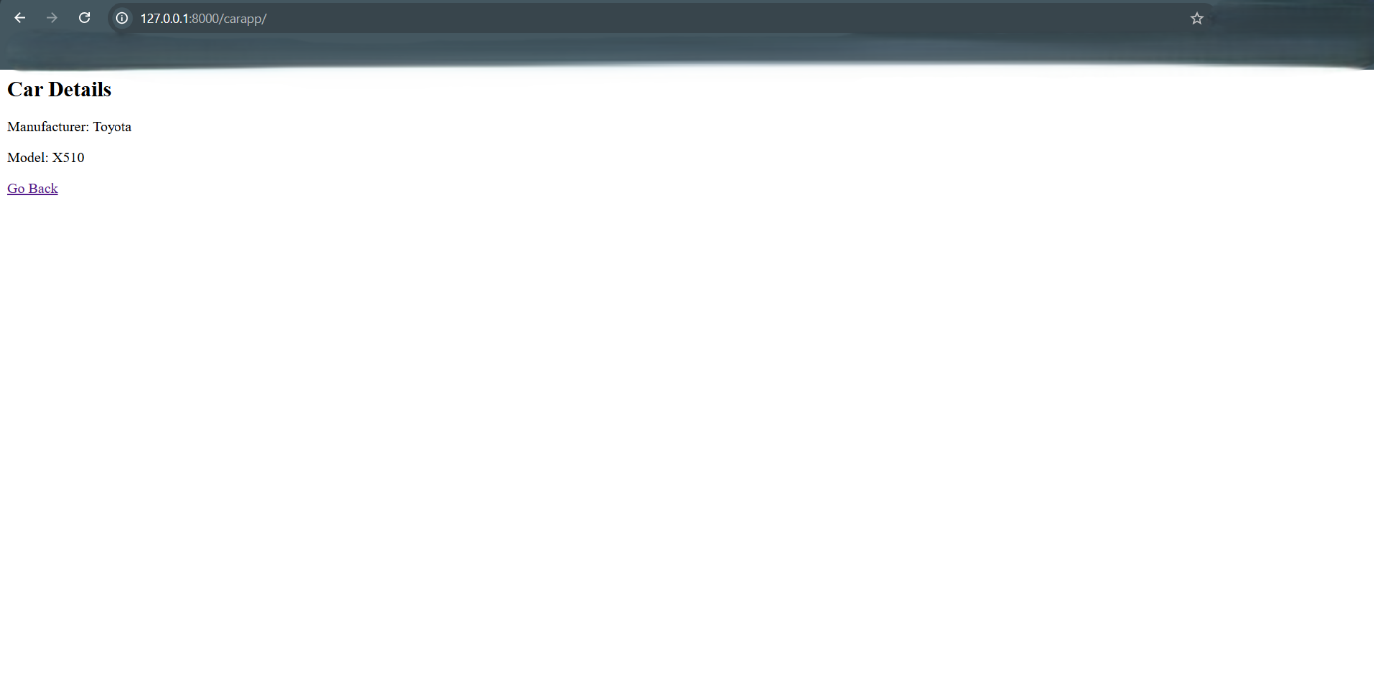

**Screenshot of session-based navigation at** [**http://127.0.0.1:8000/sessionapp/**](http://127.0.0.1:8000/sessionapp/)

**Screenshot of grocery checklist at** [**http://127.0.0.1:8000/groceryapp/**](http://127.0.0.1:8000/groceryapp/)

